**Provinces preparedness and response by region:**

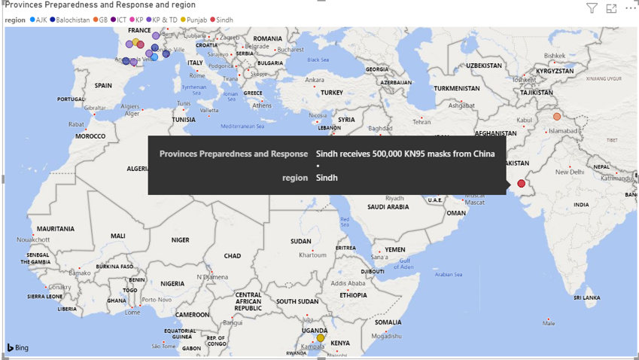

**Returnees from different countries during covid by month and date:**

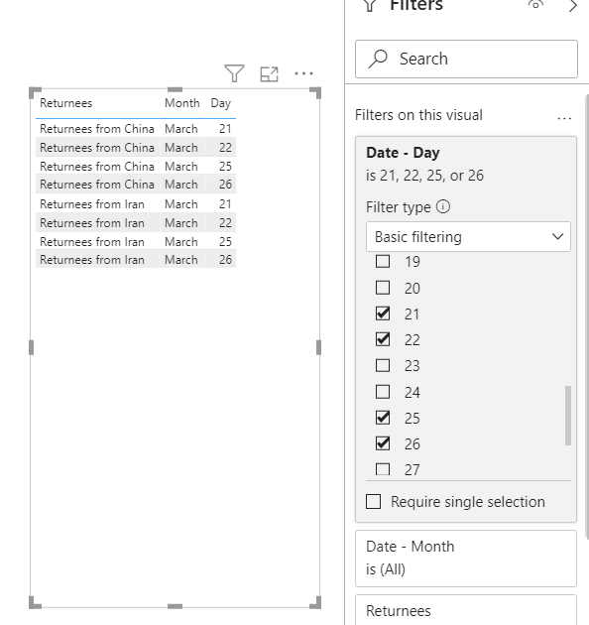

**Suspected at point of entry by Month:**

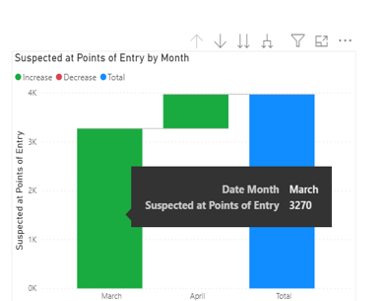

**Travelers screened in last 24 hours by Month:**

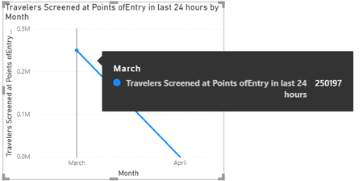

**Aggregated News by Date/Month:**

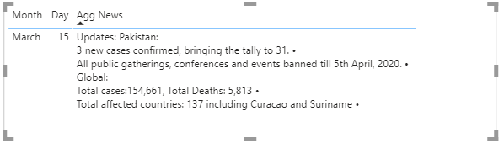

**New calls by Month:**

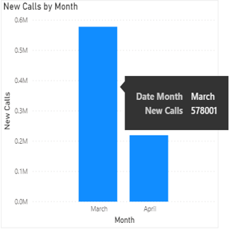

**People Discharged, Expired, Home quarantine and still Admitted by Month:**

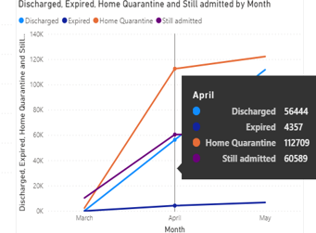

**Details (Available Bed for covid by Month):**

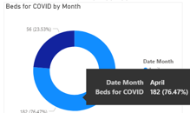

**Transmission of people% by Month:**

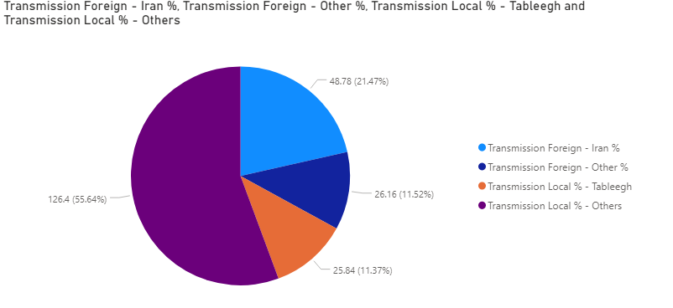

**Number of Test vs. Positive tests by provinces:**

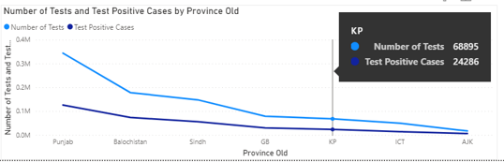

**Number of Deaths, Number of Recovered and Total Admitted by Month:**

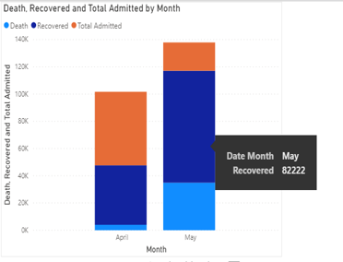

**Positive test cases and total admitted by Month:**

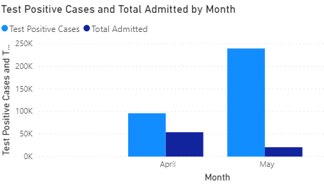

**Risk Assessment by NIH by Month/Date:**

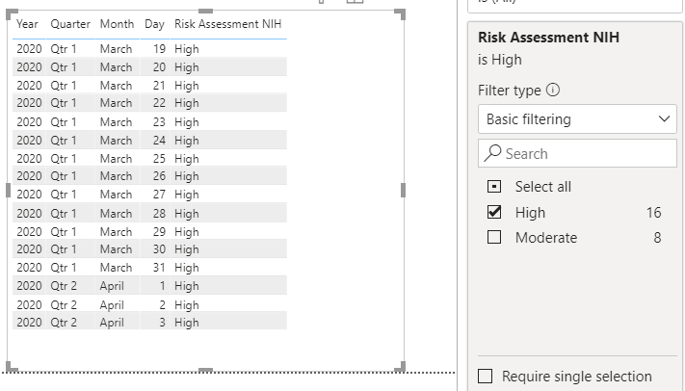

**Number of people arrived in Last 24 hours and quarantine facilities by Region:**

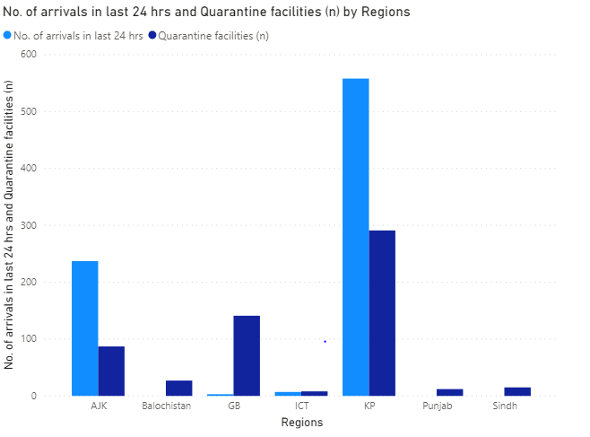

**NIH preparedness and Response by Date and Month:**

